**500 cities: Local Data for Better Health**



**FAIRFAX, VA**

**BY**

**Lakshmivaardan Chennupati**

**G01170166**

**Introduction:**

**Dataset Link:** [500 cities: Local Data for Better Health](https://catalog.data.gov/dataset/500-cities-local-data-for-better-health-b32fd)

I choose this data set as it could be helpful in building certain predictive models to analyze and predict health.

* Data set consist of (24) data variables, 810104 rows and 24 columns and size of the CSV file (235.8 Mb).
* The project was funded by the Robert Wood Johnson Foundation (RWJF) in conjunction with the CDC Foundation and provided by the Centers for Disease Control and Prevention (CDC), Division of Population Health, Epidemiology and Surveillance Branch [1] .
* This is the complete dataset for the 500 Cities project which has a total of 27 measures of chronic disease
  + Unhealthy behaviors (5)
  + Health outcomes (13)
  + Use of preventive services (9)
* The Dataset is Provided by the Centers for Disease Control and Prevention (CDC), Division of Population Health, Epidemiology and Surveillance Branch.
* Data sources used to generate these measures include Behavioral Risk Factor Surveillance System (BRFSS) data (2013, 2014), Census Bureau 2010 census population data, and American Community Survey (ACS) 2009-2013, 2010-2014 estimates [1].
* These estimates can be used to identify emerging health problems and to inform development and implementation of effective, targeted public health prevention activities[1]
* This data is very helpful in analyzing the health of the public in different location in the U.S and accordingly take preventive measures.
* The data consist of people health measures who’s age is 18 or above 18(>=18)(taken from dataset)
* This data is collected from **data.gov** and was last updated on December 7,2016

**About the Organization**:

**Who they are?**

* Centers of Disease Control and prevention (CDC) is run by Department of Health and Human Services.
* CDC also researches and provides information on [non-infectious diseases](https://en.wikipedia.org/wiki/Non-infectious_diseases) such as [obesity](https://en.wikipedia.org/wiki/Obesity) and [diabetes](https://en.wikipedia.org/wiki/Diabetes) and is a founding member of the [International Association of National Public Health Institutes](https://en.wikipedia.org/wiki/International_Association_of_National_Public_Health_Institutes).

**what do they do?**

* Their mission is to protect America from health, Safety and Security threats, in the U.S. The organization increases the health Security of the nation and saves live and protects people from health threats [2] [3].
* To accomplish this CDC collects data and provide data to some extent for the public sectors or private organization. [2]

**Need:**

**Why did they collect this data?**

This data collected is used for predicting emerging health problems and to inform development and implementation of practical, targeted public health prevention activities [1]. By using this data, this data government can have an overall idea of the health sector of each state and take precaution accordingly.

This data can also be useful private sector organization that is being in the field of health care can use this data and produce their medicines according to the location of the states for example: if we take the information for unhealth behavior, California has the highest. So pharmaceutical companies can make use of this data and make medicine accordingly which will not help profit the organization but also the help the people subsequently.

**Data Curation-** The data set had certain missing values and null values so as this missing data and null values could produce incorrect results there has to be proper data curation needs to be done which is very essential to produce good output. After removing the missing data by replacing it with a most probable value. I considered the important attributes from the given data sets to create a new one.

**Question:**

1. What is the total count of affected population of the eastern states?
2. Can this data help the government in finding the state with highest health outcome?
3. What can we analyze from the three categories in the dataset?
4. Who’s is going to benefit from the dataset and how can it help the organization?

**Requirements and Resources needed**

**Software:**

To analyze this data some of the software resources that were used are:

* + R-studios
  + Tableau
  + SQL

**Hardware Resources:**

* Laptop configuration

Operating system: Mac OS

Processor: 2.3 GHz Intel Core i5

Memory: 8 GB 2133 MHz LPDDR

Graphics: Intel Iris Plus Graphics 655 1536 MB

**Dataset Description:**

* Data set consist of (24) data variables, 810104 rows and 24 columns and size of the CSV file (235.8 Mb).

|  |  |  |
| --- | --- | --- |
| **Attributes** | **Datatype** | **Sample value** |
| Year | Interval | 2015 |
| StateAbbr | Nominal | Ny |
| StateDesc | Nominal | New York |
| City | Nominal | Texas |
| Geographical | Nominal | US |
| DataSource | Nominal | BRFSS |
| Category | Nominal | Prevention |
| UniqueID | Interval | 59 |
| Measure | Nominal | Current asthma among adults aged >=18 Years |
| Data_Value_Unit | Nominal | % |
| DatavaluetypeID | Nominal | CrdPrv |
| Datavaluetype | Nominal | Crude prevalence |
| Data value | Interval | 25.4 |
| Low confidence | Interval | 25.1 |
| High confidence | Interval | 25.6 |
| Population count | Interval | 308745538 |
| Categoryid: | Nominal | PREVENT |
| measureID: | Nominal | BINGE |
| short_Question: | Nominal | Health Insurance |

**Descriptive Statistics:**

1. **Year**

|  |  |  |  |  |  |
| --- | --- | --- | --- | --- | --- |
| Year | | | | | |
| Min | 1st Qu | Median | Mean | 3rd Qu | Max |
| 2015 | 2016 | 2016 | 2016 | 2016 | 2016 |

1. **StateAbbr**

|  |  |  |  |  |
| --- | --- | --- | --- | --- |
| StateAbbr | | | | |
| CA | TX | NY | FL | IL |
| 156778 | 89422 | 70133 | 39025 | 37458 |

1. **StateDesc**

|  |  |  |  |  |
| --- | --- | --- | --- | --- |
| StateDesc | | | | |
| California | Texas | New York | Florida | Illinois |
| 156778 | 89442 | 70133 | 39025 | 37358 |

1. **Population Count**

|  |  |  |  |  |  |
| --- | --- | --- | --- | --- | --- |
| Population Count | | | | | |
| Min | 1st Qu | Median | Mean | 3rd Qu | Max |
| 1 | 2405 | 3632 | 32024 | 5040 | 308745538 |

1. **Category**

|  |  |  |
| --- | --- | --- |
| Category | | |
| Health Outcomes | Prevention | Unhealthy Behaviors |
| 376673 | 288400 | 145030 |

1. **Data value type**

|  |  |
| --- | --- |
| Data_Value_Type | |
| Age-adjusted prevalence | Crude prevalence |
| 14028 | 796075 |

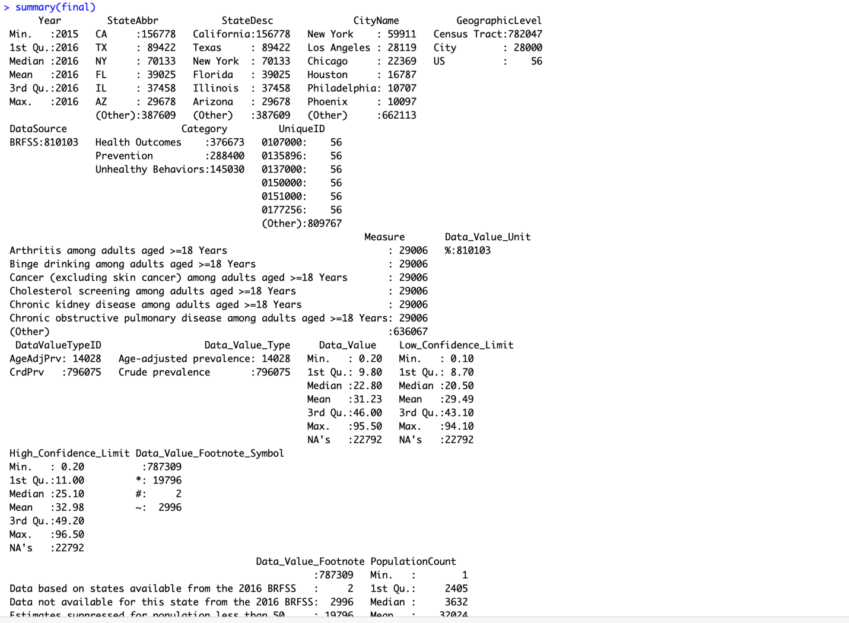

Fig(a) Summary of data (final)

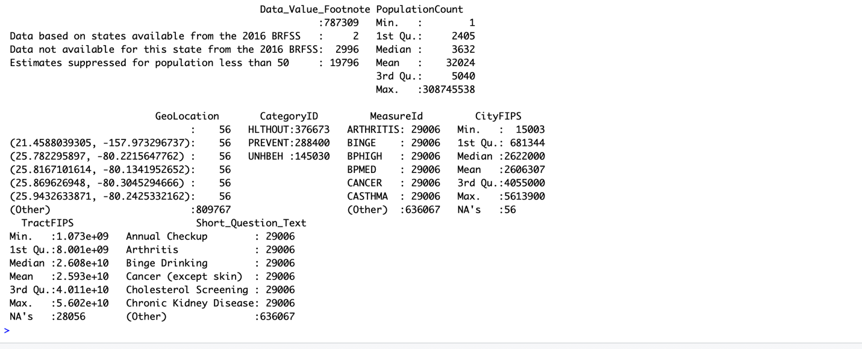

Fig(b) summary of the data (final)

Using SQL Schema:

Creating database:



Creating Table

create database MyDB;



CREATE TABLE finalproj(

Year int(5),

StateAbbr varchar(100),

StateDesc varchar(100),

CityName varchar(100),

GeographicLevel varchar(100),

DataSource varchar(10),

Category varchar(20),

UniqueID int(25),

Measure varchar(100),

Data_Value_Unit varchar(2),

DataValueTypeID varchar(10),

Data_Value_Type varchar(25),

Data_Value float(10),

Low_Confidence_Limit float(10),

High_Confidence_Limit float(10),

PopulationCount int(15),

GeoLocation varchar(50),

CategoryID varchar(10),

MeasureID varchar(10),

CityFIPS int(10),

TractFIPS int(20),

Short_Question_Text varchar(50)

);

[4]

desc finalproj;

Description of

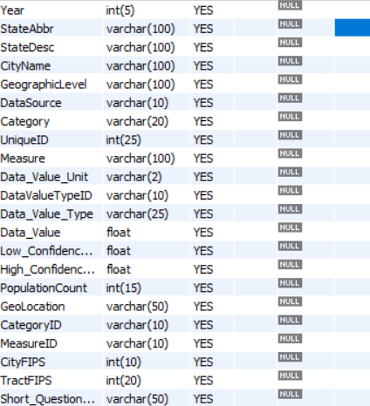

insert into finalproj values(2015,'AL','Alabama','Birmingham','City','BRFSS','Prevention',107000,'Current lack of health insurance among adults aged 18â€“64 Years',

'%','AgeAdjPrv','Age-adjusted prevalence',19.8,19.5,20.2,212237,'(33.5275663773, -86.7988174678)','PREVENT','ACCESS2',107000,0,'Health Insurance');



I have analyzed the dataset by taking the main attributes, which are essential to visualize the data using R and tableau as this could be helpful in answering the above questions with a good representation of data and could draw useful conclusion and proper understanding of the data.



Fig(c) Scatterplot for Affected Population of Eastern States in the U.S using R-studios

From the following data represented in the fig(c.) shows the analysis of registered cases in eastern states. By this we can predict that the health of people in major state like New york, Dc, Nj.

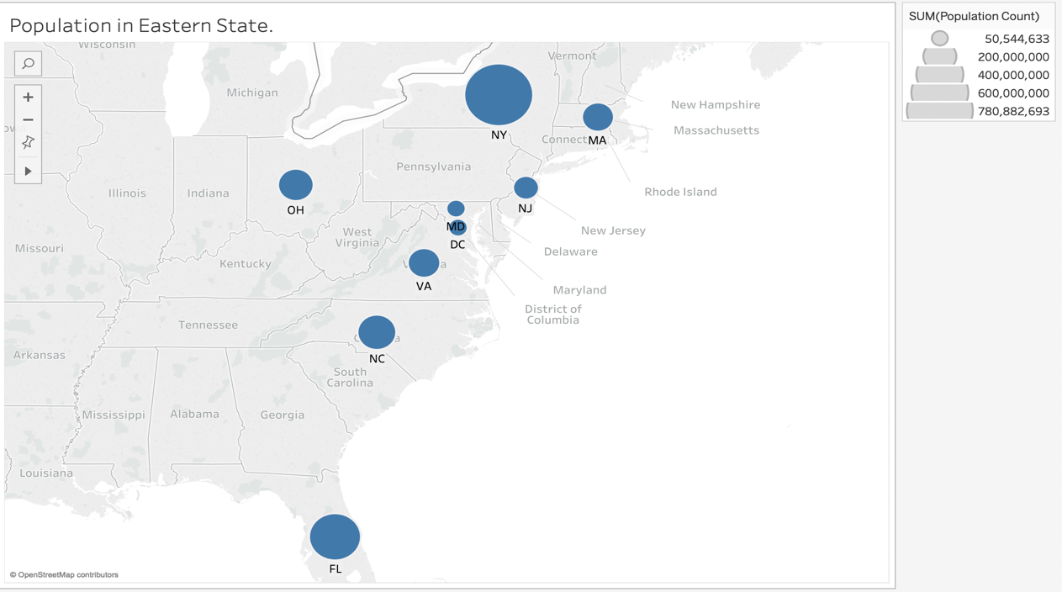

Fig(d)Map plot for Population of Eastern States in the U.S using Tableau

* The data analyzed above is taken from just the Eastern states of the U.S.
* As the population increases the risk of begin affected by diseases also increases. For instance, as we can see from the above plot fig(d)in New York people are more prone to health outcomes like Asthma, Coronary heart disease, Chronic obstructive pulmonary etc. Compared to other states like DC and Maryland. But as we can see that there is a correlation all three and dude to less prevention taken the health outcome might increases.

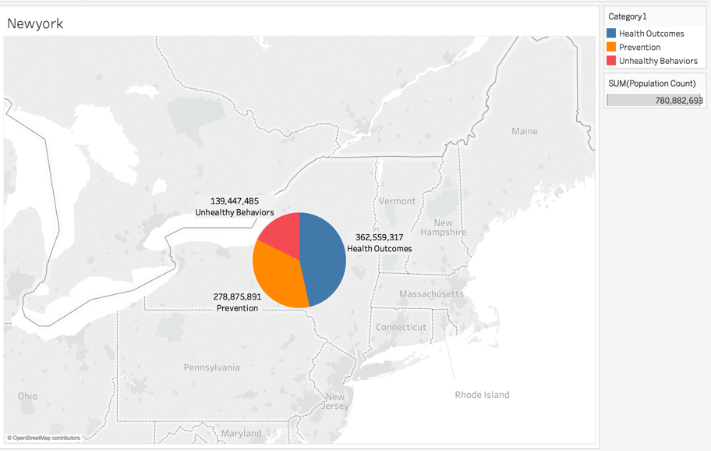

**Fig(e) Analyzing according to Category in New York**

We can take the information from the eastern state of New York that unhealthy Behaviors is low. But when health outcome increases unhealthy behavior may also increases along with it. So, taking prevention this can reduce the health conditions.

**Boxplot:**

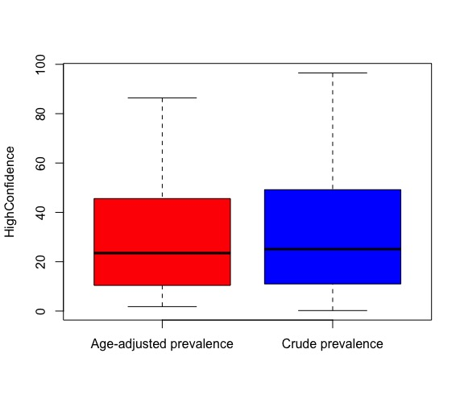

Fig(g) BoxPlot for HighConfidence for Age-Adjusted prevalence and Crude prevalence

In the above Box plot Crude prevalence for High Confidence has slightly higher mean value than Age-adjusted prevalence. This data shows that the strength of the cases are more and cases registered in the total population are higher than death total and we can see that the 3rd quartile for crude prevalence is higher than age adjusted prevalence.

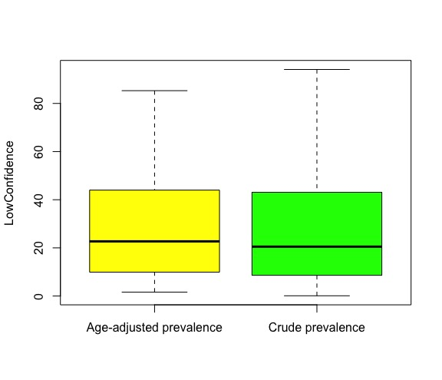

Fig(h) Boxplot for Low Confidence for Age-Adjusted prevalence and Crude prevalence

In the above Box plot Crude prevalence for low Confidence has slightly lower mean value than Age-adjusted prevalence. This data shows that there are less cases registered in the total population than total death and we can see that the 3rd quartile for crude prevalence is higher than age adjusted prevalence.

**Category Representation**



Fig(i) Bubble pot Category Representation for Total population in the dataset

As we can analyze from the above plot that chance of getting diseases such as Pulmonary disease, Asthma, Arthritis (health Outcome) for the people of age18 or above 18 in the United states are more compared to that of Prevention that are made for the diseases and the people who have already been affected by this disease are less compared to prevention made and Health Outcomes. This also gives us information that there is less prevention taken in the U.S and health Outcome might increase in the future.

In the above fig(i) we can analyze that the dataset given to us has more number of outcome that are predict by the organization CDC and less number of unhealthy behavior.

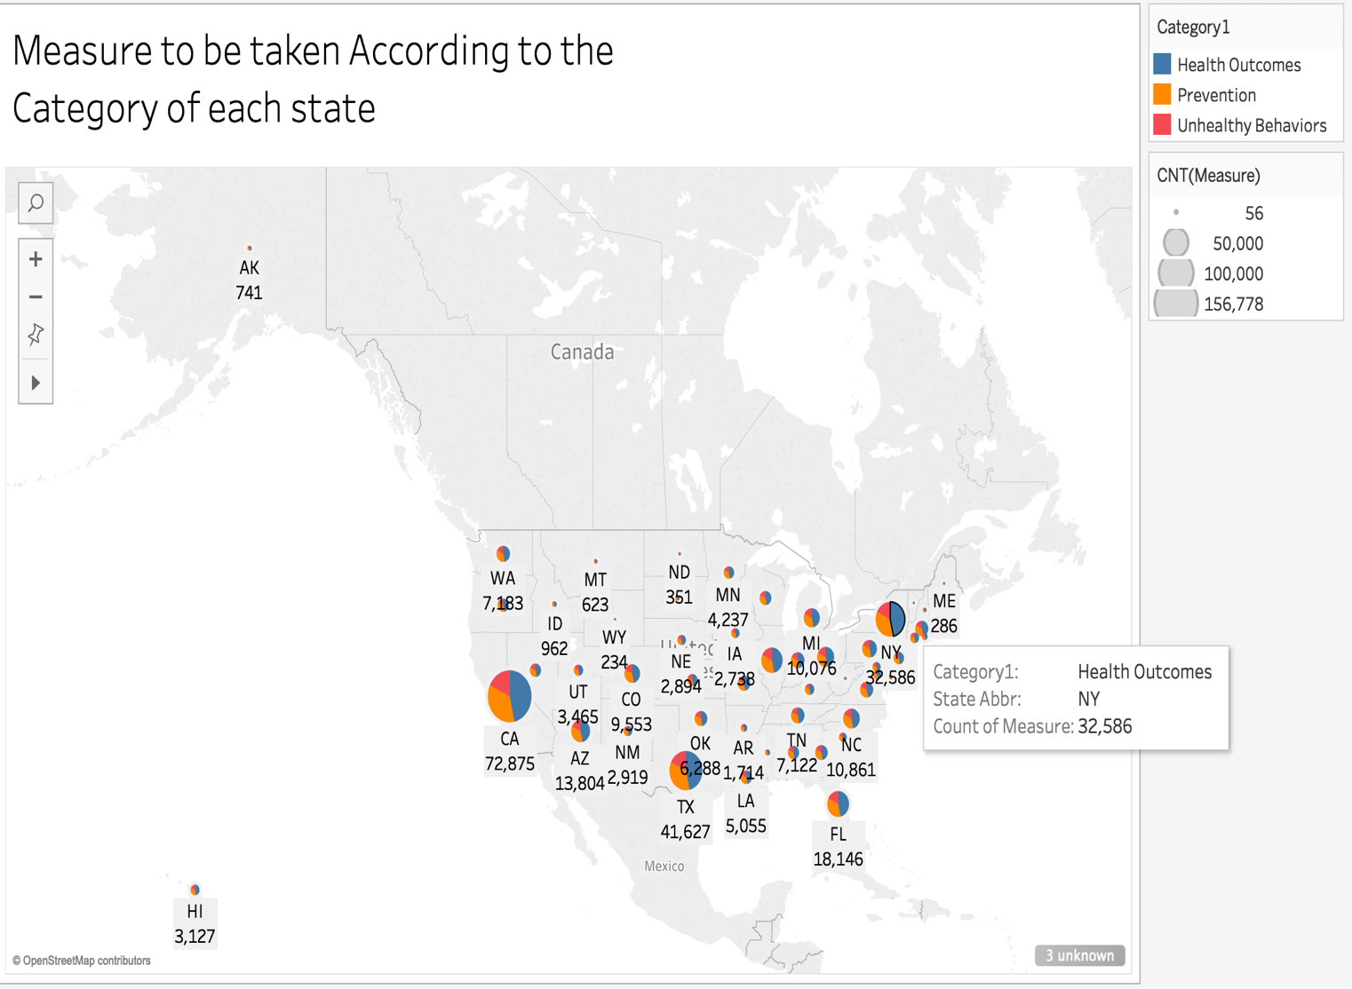

Fig(j)Measure to be taken According to the Category of each State

This data can help the government find the state with the highest health outcome. We can analyze that in a major city like California, New York, Texas and Florida preventative measures are lacking. From the figure (j) California has the highest recorded cases so far, and the health outcome for California is 72,875. which show that the population in the major cities have more chance of getting affected by diseases than the people in living in the countryside. So accordingly, government can take necessary precaution in the particular location to reduce the outcome and increases prevention.

For example:

When we take a high populated city like New York where the data fig(j) represents 32,586 health outcomes which are registered cases and compared to that of North Dakota state where it has only 351 of the cases registered which is a huge margin that show that people living in metropolitan have higher rate of outcomes.

We can also analyze that from this fig(j) the lower part of the U.S have higher registered cases than the upper part and assuming that the once near the costal line are once that has recorded high cases.



Fig(k)Boxplot

We can also see in the fig(k) that California is the has the highest registered cases in all the category’s such as health outcome, prevention, Unhealthy Behavior.

**Correlation:**

* They are independent of each other .As they are negatively corelated
* For every one unit increases in data value the population count decreases by -7.228071e-05units.
* There exists a negative correlation between data value and population count.

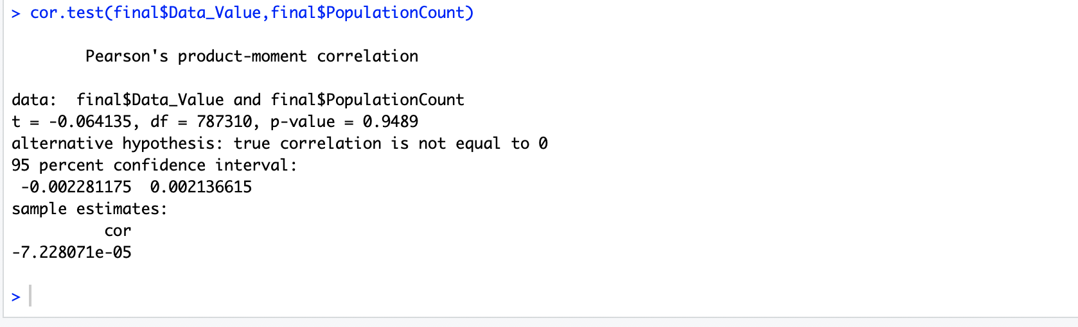

Fig(l)Correlation test

**Hypothesis:**

* Null hypothesis= data value and population count are equal
* Alternate hypothesis=data value and population are not equal
* When p value is 0.9498 which is higher than 0.5 i.e. we accept null hypothesis
* So the data value and population count are equal.



Fig(m).shows the hypothesis

**Regression:**

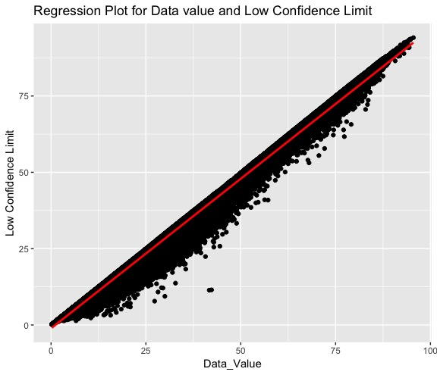

Fig(n)Regression plot

Low confidence is dependent on high confidence with slop and intersect and the p-value has rejected the null hypothesis.

**Regression Model:**

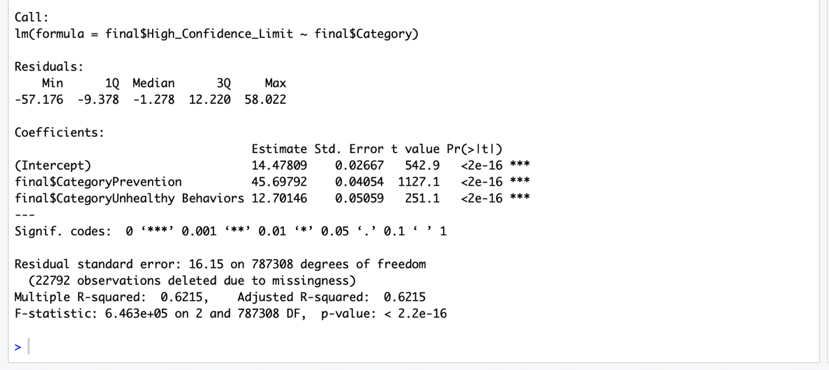

Fig(o)Regression model

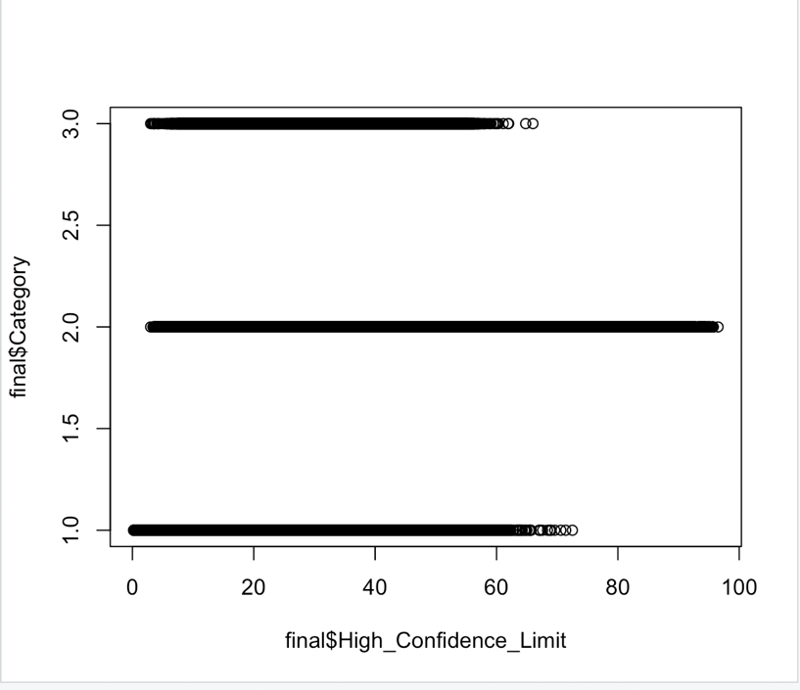

Fig(p)Correlation plot

**Benefits of data:**

**Government:**

United states can use this data to carful increases precaution and spread awareness about the health outcome that might have a huge impact in the future.

**Public sector:**

This data can also be useful private sector organization that is being in the field of health care can use this data and produce their medicines according to the location of the states for example: if we take the information for unhealth behavior, California has the highest. So pharmaceutical companies can make use of this data and make medicine accordingly which will not help profit the organization but also the help the people subsequently.

**Data Terms:**

**Crude**: Rates are quite simple and straightforward. They are calculated by dividing the total number of cases in a given time period by the total number of persons in the population. In this case Population B has a higher crude rate of disease [4].

**Age**-**Adjusted:**  The age-adjusted rates are rates that would have existed if the population under study had the same age distribution as the "standard" population. Therefore, they are summary measures adjusted for differences in age distributions [5]

**Curation:**

This is one of techniques which involves cleaning the data completely in order to remove missing data, null values if present they could be removed by replacing the missing data with a most probable value, or using a mean, median value. On proper data curation, it could retain the quality of data that could be helpful in getting a good outcome.

# Reference

|  |  |
| --- | --- |
| [1] | RWJ, "Robert Wood Johnson Foundation.," 2001. [Online]. Available: https://www.rwjf.org/. |
| [2] | Goverment, "Center For Disease Control and prevention," [Online]. Available: www.cdc.gov/500cities.. |
| [3] | wikipiedia, "Control for dieases control and prevention," [Online]. Available: [3]https://en.wikipedia.org/wiki/Centers_for_Disease_Control_and_Prevention. |
| [4] | w3schools, "w3school," [Online]. Available: https://www.w3schools.com/sql/sql_create_db.asp. |
| [5] | M. P. M. Wayne W. LaMorte, "Standardized Rates of Disease," 2016. [Online]. Available: http://sphweb.bumc.bu.edu/otlt/MPH-Modules/EP/EP713_StandardizedRates/EP713_StandardizedRates2.html. |
| [6] | R. W. Williams, "Missouri DHSS," 1998. [Online]. Available: https://health.mo.gov/data/mica/CDP_MICA/AARate.html. |
| [7] | RWJ, "Robert Wood Johnson Foundation," 2001. [Online]. Available: https://www.rwjf.org/. |